Daily Stand-Up Meeting
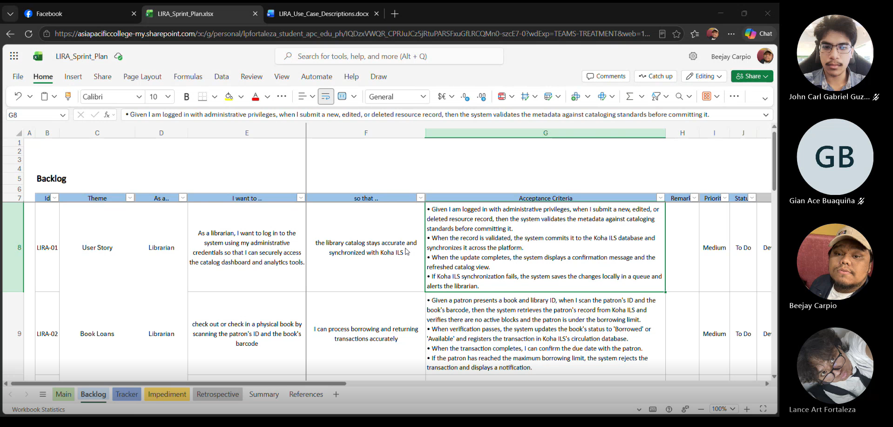

Minutes of meeting
Date: 09/15/2026
Meeting Called By: Cache Flow

Attendees
Gian Ace Buaquiña
Beejay A. Carpio
Lance Art P. Fortaleza
John Carl Gabriel Guzman

Summary
We reviewed the updates to the Use Case Diagram, specifically adding the "Borrow Book" use case connected to Koha. To avoid development delays, Gian created a new private GitHub repository for team collaboration and backup while waiting for final repository confirmations.

What we did yesterday:
The team set up the project backlog and tracker, organized the SharePoint and Teams documentation folders, divided team roles.

What we did today:
The team created the new GitHub repository and build the student side UI first.

